Name: Archana Devi.P
Reg Number: 192521192
Course: Programming in Java
Code: CSA0923
Github Link: https://github.com/Archix17/CSA0923-JAVA
ASSIGNMENT 4

ASSIGNMENT 4 – CO4: Event-Driven GUI Design
TASK 1 – GUI Design Review
Task 1.1 – Diagnose the Design
The given fee-payment program has the following design deficiencies:
No. | Design deficiency | Problem caused
1 | UI and payment logic are combined | Difficult to maintain and test
2 | Uses == for String comparison | Action command comparison may fail
3 | No input validation | Empty or invalid amounts can cause errors
4 | Database operation runs on the event-dispatch thread | Window may freeze during payment
5 | Uses Thread.sleep(3000) | GUI becomes unresponsive for three seconds
6 | SQL statement uses string concatenation | Vulnerable to SQL injection
7 | No user feedback | User cannot clearly know whether payment succeeded
8 | Receipt button has no separate functionality | User cannot view the payment receipt
9 | Database connection is not closed | May cause resource leaks
10 | No window-closing handler | Window may not close cleanly

Task 1.2 – Repair the Design
Aim
To redesign the fee-payment application by separating the GUI and payment logic using two classes: FeeWindow and FeeService.
Proposed class structure
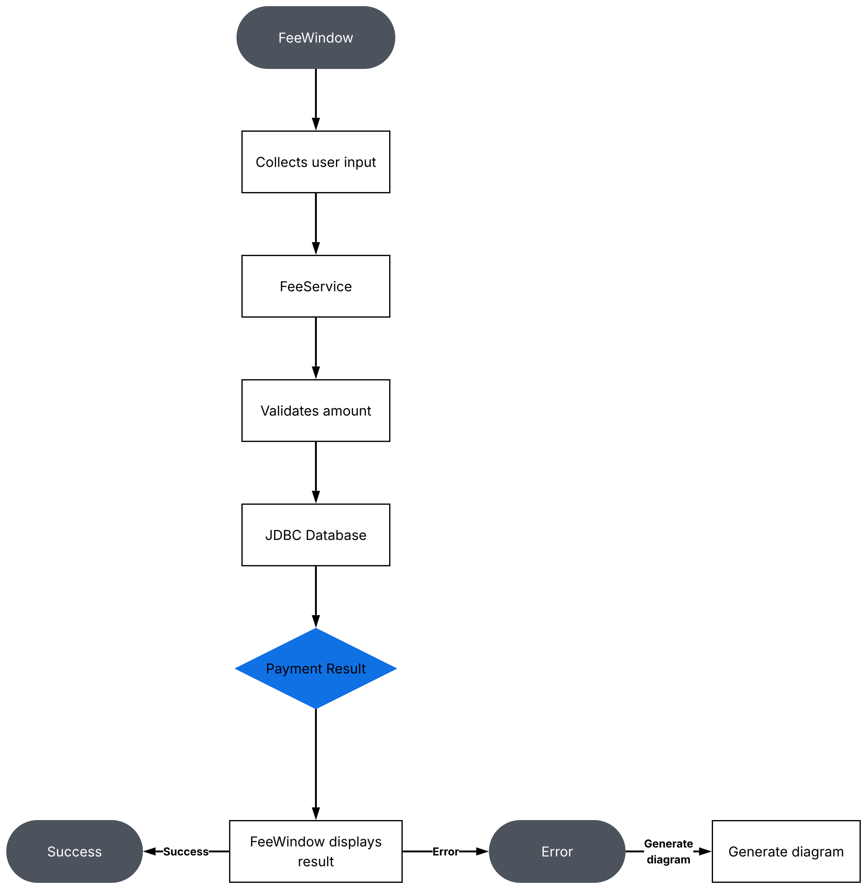

Class responsibilities:
Class | Responsibility
FeeWindow | Displays the window, collects input and displays messages
FeeService | Validates input and performs payment
Database | Stores payment information

Algorithm
- Create the fee-payment window.
- Enter the registration number and amount.
- Click the Pay button.
- Validate the entered values.
- Send the payment request to FeeService.
- Save the payment using JDBC.
- Display success or error feedback.
- Click Receipt to view the last payment.
- Click Clear to clear the fields.
Java program – Repaired design
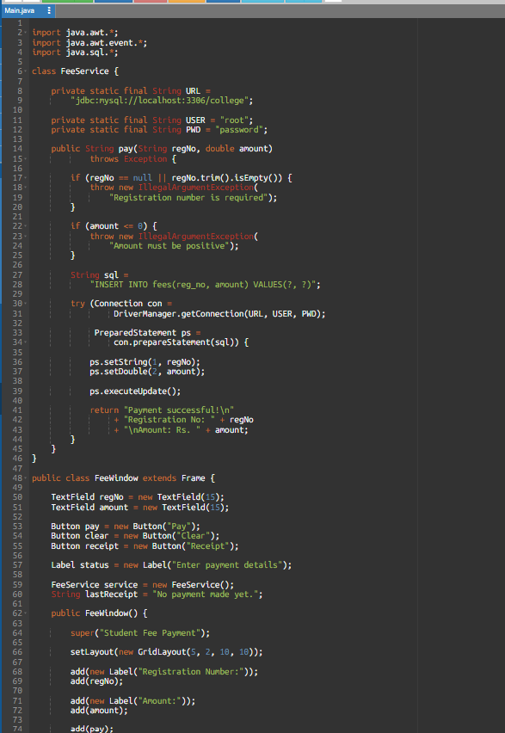
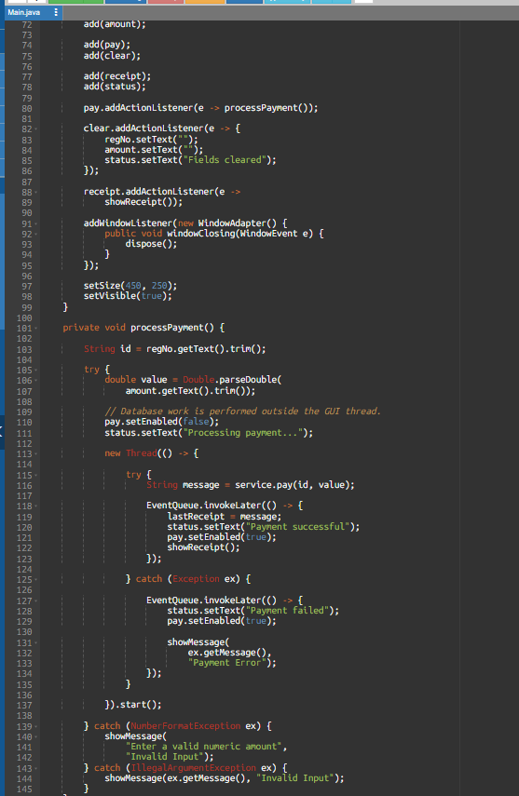
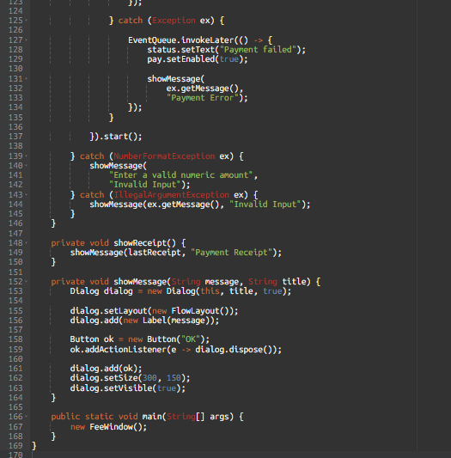
Expected behaviour
Action | Expected result
Enter valid details and click Pay | Payment saved and success message shown
Enter letters in amount | Invalid amount message
Leave registration number empty | Registration number error
Enter zero or negative amount | Positive amount error
Click Clear | All fields cleared
Click Receipt | Last payment details displayed
Close window | Window closes properly

Task 1.3 – Design Defence
- The redesigned program separates the user interface from the payment logic.
- FeeWindow handles user input and displays messages, while FeeService performs validation and database operations.
- This separation makes the program easier to test, debug and maintain. Changes to payment rules can be made in FeeService without modifying the GUI.
- PreparedStatement improves database security, and background execution prevents the window from freezing during payment processing.
Alternative Concept and Complexity Analysis
Instead of one listener with an if-else chain, each button can have its own listener object.

Example:
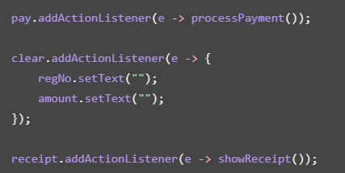
Method | Event dispatch | Space
One listener with k command comparisons | Worst-case O(k) comparisons | O(1) listener
Separate listener objects | O(1) handler dispatch | O(k) listener objects

- With separate listeners, each button has its own action.
- This improves readability and makes changes easier. In larger Swing applications, shared Action objects can also be used across buttons, menus and keyboard shortcuts.
TASK 2 – FROM REQUIREMENT TO EVENT-DRIVEN DESIGN
Problem: Hospital Outpatient Appointment Desk
Task 2.1 – Model the Events
Aim: To identify the event sources, event objects, listener interfaces and actions in a hospital appointment application.
An event is generated when a user interacts with a GUI component.
Event source | Event object | Listener interface | Action
Patient ID field | ActionEvent | ActionListener | Read patient ID
Department ComboBox | ActionEvent | ActionListener | Refresh doctor list
Doctor ComboBox | ActionEvent | ActionListener | Select doctor
Time slot ComboBox | ActionEvent | ActionListener | Select appointment time
Book button | ActionEvent | ActionListener | Validate and book appointment
Window | WindowEvent | WindowListener / WindowAdapter | Handle closing
Cancel button | ActionEvent | ActionListener | Clear entered details

Task 2.2 – Design the Component Hierarchy
Aim: To design the containment structure of the appointment window using Swing components.
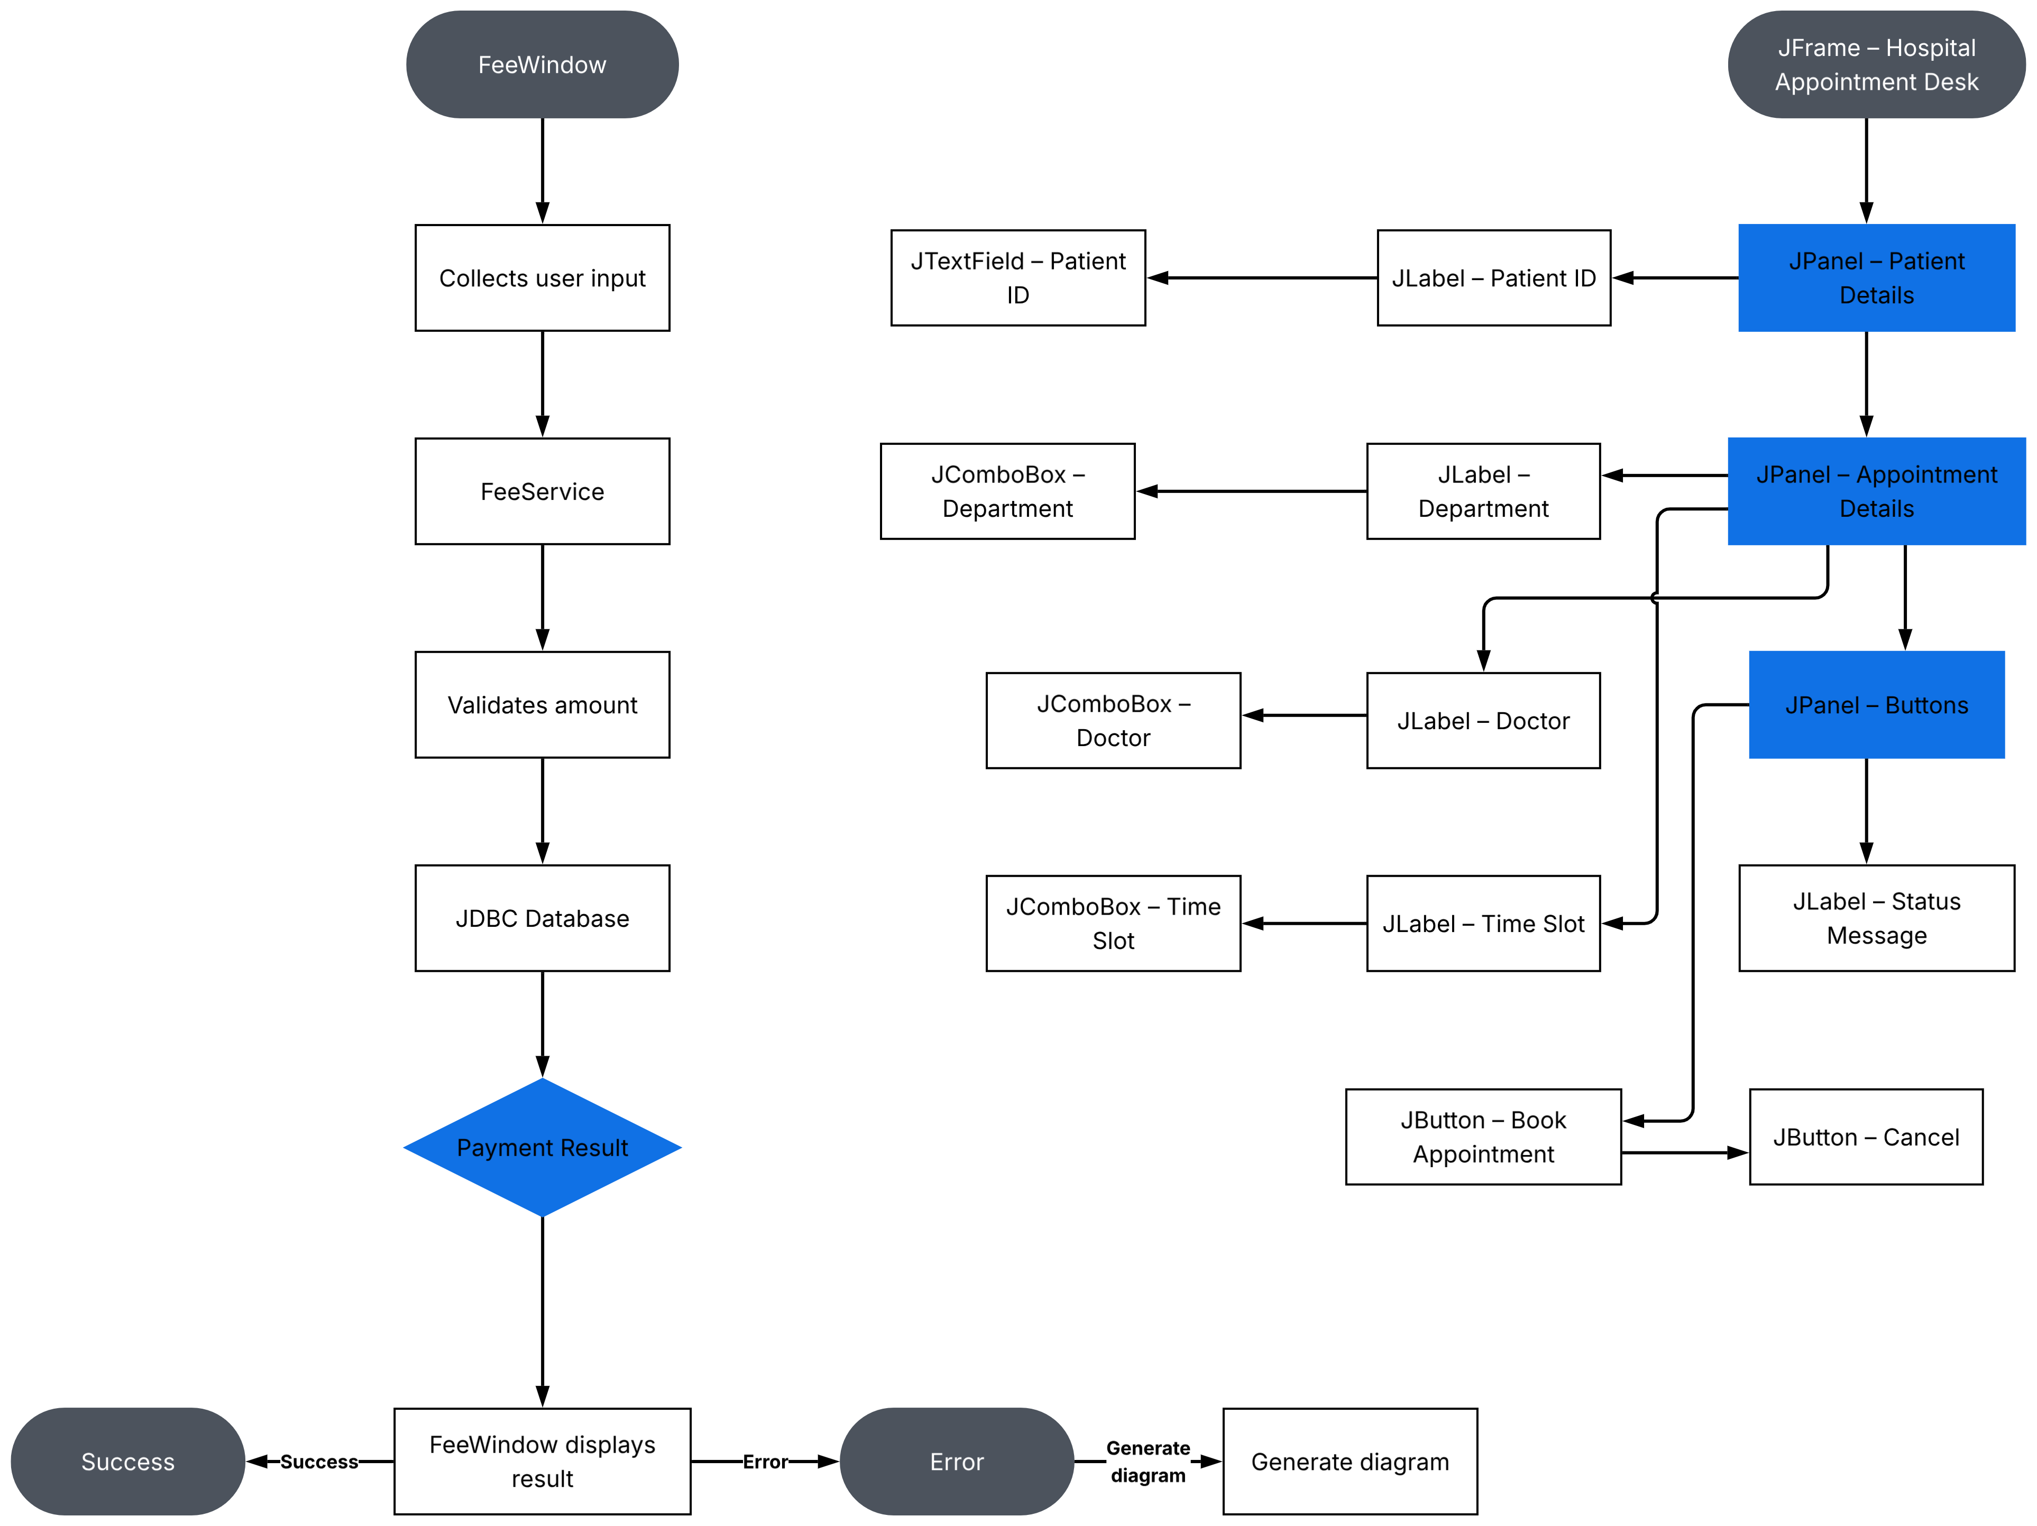

Components used:
Component | Purpose
JFrame | Main application window
JPanel | Groups related components
JLabel | Displays labels and messages
JTextField | Accepts patient ID
JComboBox | Displays department, doctor and time choices
JButton | Performs booking and cancellation
JOptionPane | Displays confirmation and error dialogs

Task 2.3 – Design the Handler Logic
Aim: To write pseudocode for refreshing the doctor list and booking an appointment.
(a) Pseudocode – Refresh doctor list
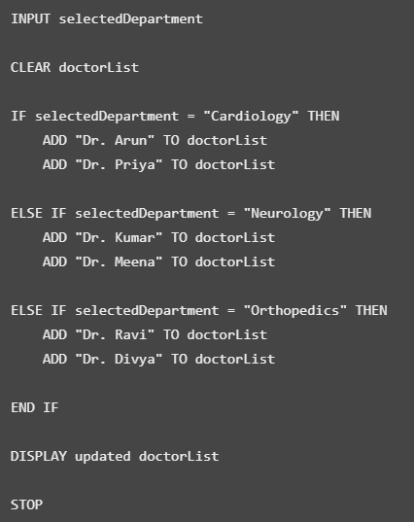
(b) Pseudocode – Validate and book appointment
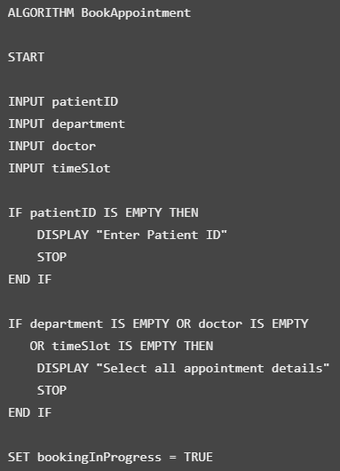
Task 2.4 – Trace the Event Sequence
Aim: To understand the order of method calls from opening to closing the window.
Event sequence
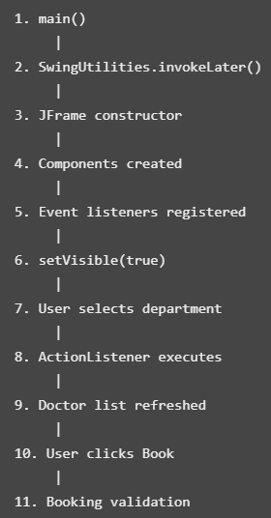
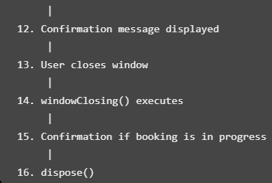
Comparison with applet life cycle
Applet method | Purpose
init() | Initializes the applet
start() | Starts or resumes execution
paint() | Draws the applet
stop() | Pauses execution
destroy() | Releases applet resources

A Swing JFrame does not use the applet life-cycle methods. It is controlled through its constructor, event listeners, visibility and disposal.
Java program – Hospital Appointment Desk
Aim: To implement an appointment booking GUI using Swing event handling.
This program uses a Map<String, List<String>> to store doctors according to their departments. It also asks for confirmation before closing while a booking is in progress.
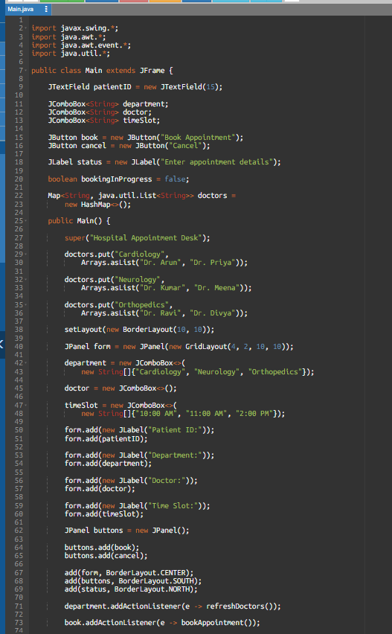
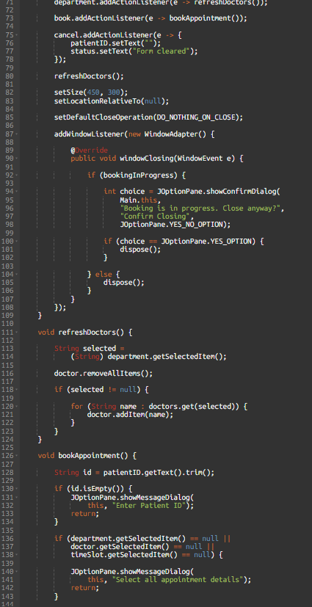
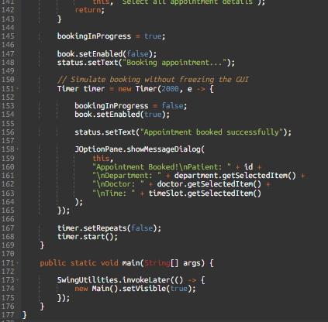

When the application opens:
- Enter a patient ID.
- Select a department.
- The doctor list changes automatically.
- Select a time slot.
- Click Book Appointment.
- A confirmation message appears after the simulated booking.
Alternative Concept and Complexity Analysis
Instead of loading doctors once into a Map, the program could fetch doctors from a database every time the department changes.
Approach | Time per department change | Memory
Preloaded Map | O(1) average lookup + O(dᵢ) to display doctors | O(d + m)
Database fetch | Query/network time + O(dᵢ) to display doctors | O(dᵢ) for current results

Here:
- d = number of departments.
- m = total number of doctors.
- dᵢ = number of doctors in the selected department.
- The Map approach is faster for repeated selections because the data is already loaded.
- Database fetching uses less application memory if only the selected department's doctors are loaded, but it requires a database request each time.
Conclusion
- The hospital appointment application uses Swing components and event listeners to handle user actions.
- The Map dynamically refreshes the doctor list when the department changes.
- Validation prevents incomplete bookings, and a window listener handles closing during an active booking.
TASK 3 – FROM SKETCH TO LAYOUT
Problem: Campus Library Search Screen
Task 3.1 – Choose the Layout Managers
Aim: To select suitable Java layout managers for a library search screen that resizes correctly.
The application contains:
- A title at the top.
- A search row containing a text field, category selection and Search button.
- A results area in the centre.
- Prev, Next and Reserve buttons at the bottom.
- A status message.
Layout manager selection
Layout manager | Where used | Reason
BorderLayout | Main JFrame | Divides the window into five regions
FlowLayout | Search panel | Arranges search components in a row
FlowLayout | Button panel | Arranges buttons horizontally
BorderLayout | Bottom panel | Separates buttons and status message
BorderLayout | Results container | Allows the results area to expand

Why BorderLayout?
- The centre region receives the extra space when the window is resized.
- Therefore, the results area grows while the search and button rows remain compact.
Why FlowLayout?
- FlowLayout arranges the search components and buttons horizontally without stretching them to fill the entire window.
Task 3.2 – Design the Nested Containers
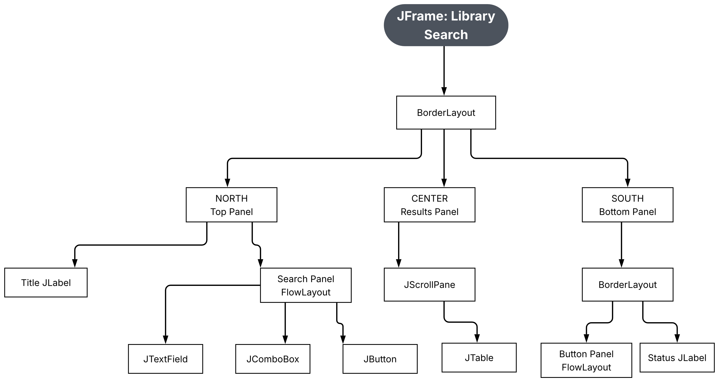
Task 3.3 – Implement the Screen
Aim: To create a library search screen using Swing and nested layout managers.
Algorithm
- Create a JFrame.
- Set the main layout to BorderLayout.
- Create the title label.
- Create the search panel using FlowLayout.
- Add a search text field, category combo box and Search button.
- Create a JTable to display the results.
- Place the JTable inside a JScrollPane.
- Create Prev, Next and Reserve buttons.
- Add a status label.
- Display the window.
Complete Java program
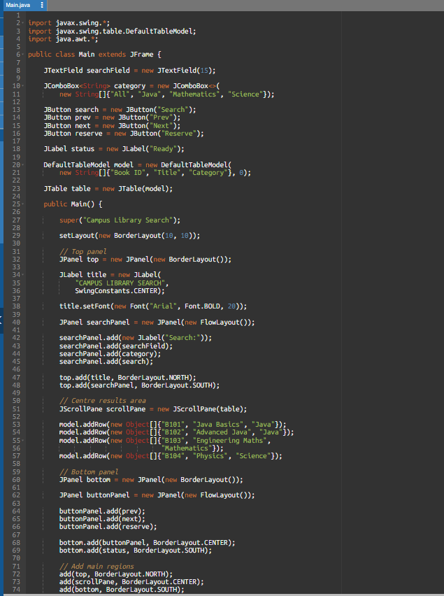
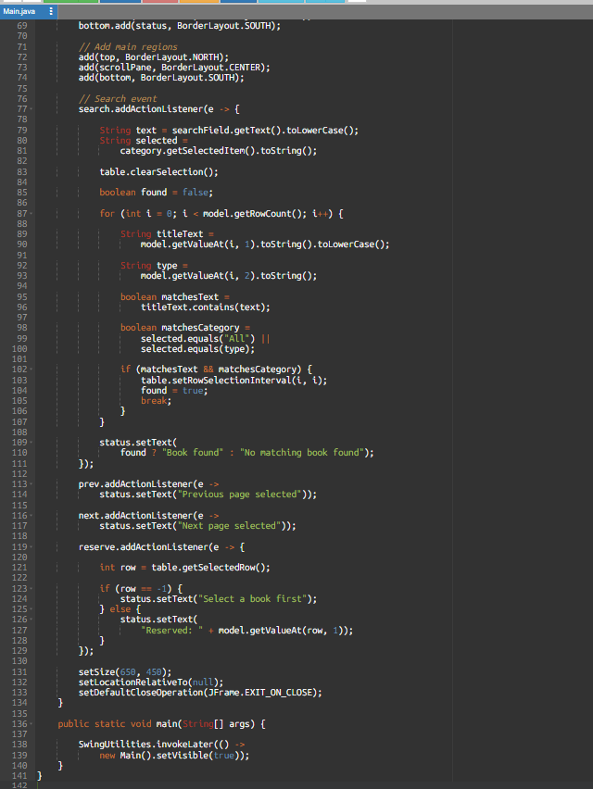
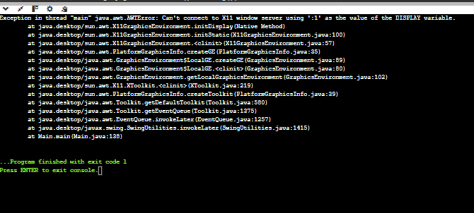
Task 3.4 – Test the Resizing Behaviour
Test | Window size | Expected behaviour
1 | 650 × 450 | Normal display
2 | 900 × 600 | Results area becomes larger
3 | 450 × 350 | Results area becomes smaller; controls remain arranged
- When the window is resized, the centre results area expands or contracts automatically.
- The search row and button row remain arranged horizontally because they use FlowLayout.
- Therefore, BorderLayout and nested panels satisfy the resizing requirement.
Alternative Concept and Complexity Analysis
Option 1 – GridBagLayout
GridBagLayout allows more precise positioning and resizing using constraints. It is flexible but requires more configuration.
Option 2 – Absolute positioning
Absolute positioning uses:
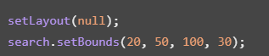
It requires manually specifying each component's position and size. When the window is resized, the components may overlap or remain in unsuitable positions.
Design | Resizing | Maintenance
Nested BorderLayout and FlowLayout | Good | Easy
GridBagLayout | Very good with correct constraints | More complex
Absolute positioning | Poor | Difficult

- Complexity: For c GUI components, a layout pass generally requires O(c) work for simple layouts, although actual layout cost depends on the layout manager and nested containers.
- The nested design uses a small number of panels, approximately O(c) space for components and containers.
- GridBagLayout also uses O(c) component space but has additional constraint data. Absolute positioning stores bounds for each component, also O(c) space.
Conclusion
- The library search screen uses BorderLayout for the main window and FlowLayout for the search and button panels.
- The results area automatically grows when the window is resized. This design is flexible, simple and easy to maintain.
TASK 4 – EVENT-HANDLING FORENSICS
Problem: Drawing Pad
Task 4.1 – Locate the Defect
Aim: To identify the errors in the drawing pad's event-handling code.
There are two main defects:
Defect 1 – Incorrect method name
The code uses:
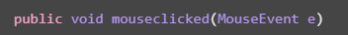
The correct method name is:
Java is case-sensitive. The MouseAdapter method is mouseClicked, with an uppercase C. Therefore, the incorrectly named method does not override the required listener method, and the click event is not handled by that method.
Defect 2 – Label is not updated
The program increments count, but it never updates the label using status.setText().
Therefore, the label continues displaying:
Task 4.2 – Construct a Failing Interaction
Aim: To demonstrate why drawing directly using getGraphics() is unreliable.
Perform these steps:
- Open the drawing pad.
- Click several locations.
- Dots appear on the window.
- Minimise the window.
- Restore the window.
- Observation: The previously drawn dots may disappear.
- Reason: getGraphics() draws directly onto the current screen. These drawings are temporary. When the window is repainted, the program does not have stored information about the old dots, so they cannot be drawn again.
- The correct approach is to store every clicked point in a collection and redraw all points inside paint().
Task 4.3 – Repair the Program
Aim: To implement a drawing pad that counts clicks, updates the label and preserves dots after repainting.
Algorithm
- Create a Frame.
- Create a list to store clicked points.
- Add a MouseListener.
- Override mouseClicked() correctly.
- Store the clicked location in the list.
- Increment the click count.
- Update the status label.
- Call repaint().
- Override paint() to draw every stored point.
- Close the window using WindowAdapter.
Complete the Code – TODO 1 and TODO 2
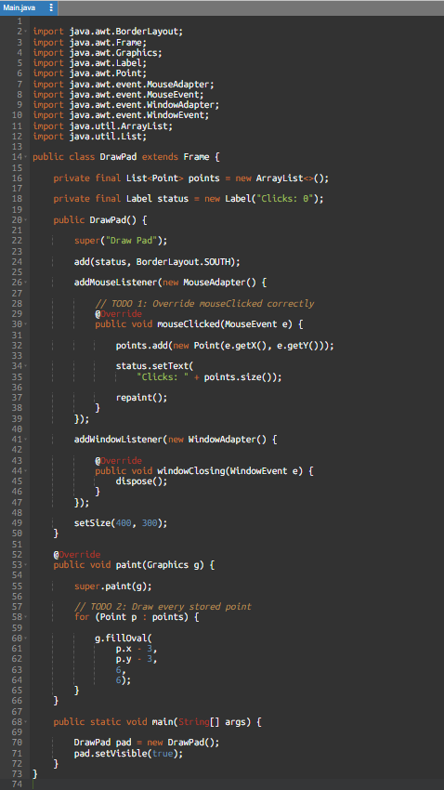
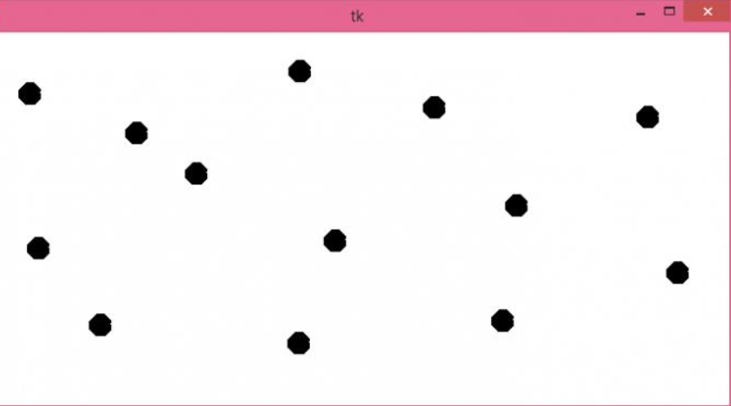
When you click the window:
- A dot is drawn at the clicked location.
- The click counter increases.
- The dots remain after minimising and restoring the window.
Example:
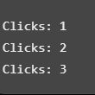
Task 4.4 – Prevent Recurrence
Question: How would @Override expose the first defect?
- The @Override annotation tells the compiler that a method must override a method from its parent class or interface.
- If we write mouseclicked() instead of mouseClicked(), the compiler reports an error because no matching method is being overridden.
- This helps identify spelling and capitalization mistakes before execution.
Alternative Concept and Complexity Analysis
Instead of storing individual Point objects, the program could draw onto an off-screen BufferedImage.
Example:
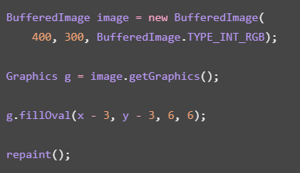
In paint(), the program would copy the image to the window using:
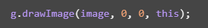
Approach | Repaint time | Storage
Store points and redraw | O(n) for n dots | O(n)
BufferedImage | O(width × height) for a full image copy | O(width × height) pixels

- The point-list approach uses less memory when there are only a few dots.
- BufferedImage is useful for more complex drawing because the drawing is retained in the image rather than recreated from individual points.
Conclusion
- The main defects were incorrect method overriding and failure to update the label.
- Storing points and drawing them inside paint() ensures that the dots remain visible after repainting.
TASK 5 – SAME SCREEN, DIFFERENT EVENT-HANDLING STYLES
Problem: Currency Converter
Task 5.1 – Four Implementations
Aim: To implement the Convert action using four different event-handling techniques in Java Swing.
The four techniques are:
- Frame implements ActionListener.
- Named inner class.
- Anonymous inner class.
- Lambda expression.
All four versions perform the same currency conversion.
Common conversion logic
The application accepts an amount in INR and converts it into USD or EUR.
Currency | Conversion rate used
USD | 0.012
EUR | 0.0112
These are fixed demonstration rates, not live exchange rates.
(a) Frame implements ActionListener
The JFrame itself implements the ActionListener interface.
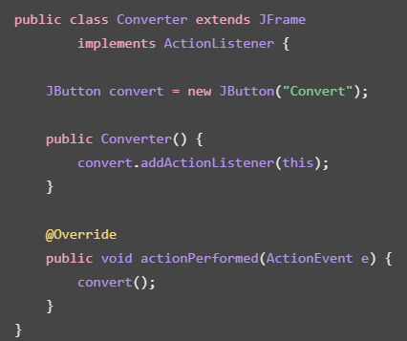
Explanation: The frame receives the button event and calls the conversion method.
(b) Named inner class
A separate inner class handles the button event.
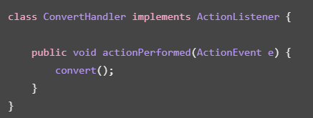
Register the listener:
Explanation: The named inner class keeps the event-handling code separate from the GUI construction.
(c) Anonymous inner class
An anonymous class is created directly while registering the listener.
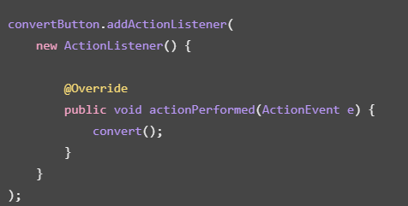
Explanation: No separate class name is required. The event-handling code is written directly inside the registration statement.
(d) Lambda expression
A lambda expression provides a shorter way to write the event handler.
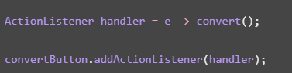
Explanation: Lambda expressions reduce unnecessary code when implementing functional interfaces such as ActionListener.
Task 5.2 – Change the Requirement
The converter must also:
- Convert when the user presses Enter in the amount field.
- Display the conversion result in a dialog box.
For each implementation, register the same handler with both the button and the amount field.
Style | Button event | Enter key event
Frame implements ActionListener | convertButton.addActionListener(this) | amount.addActionListener(this)
Named inner class | new ConvertHandler() | Same handler object
Anonymous inner class | Shared anonymous listener object | Same listener object
Lambda | Shared lambda listener object | Same listener object

Complete the Code – TODO 1 and TODO 2
This is the lambda version from your screenshot.
Aim: To implement a currency converter using one lambda listener for both the Convert button and Enter key.
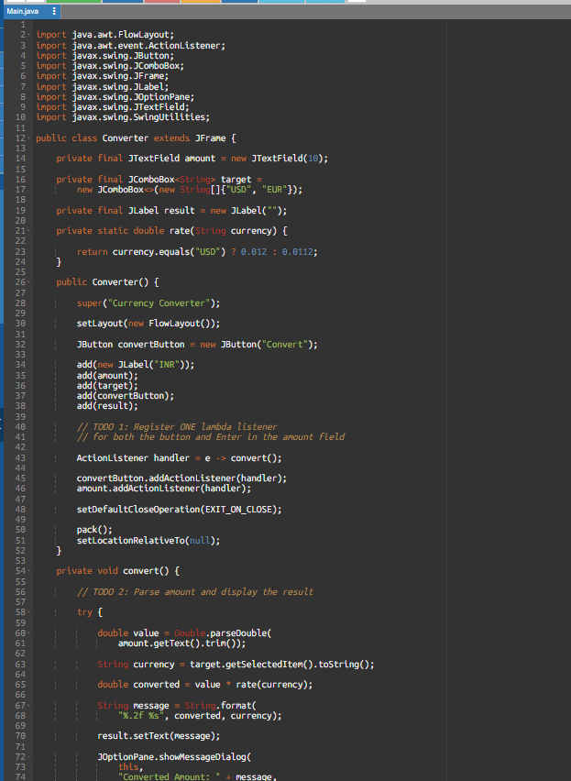
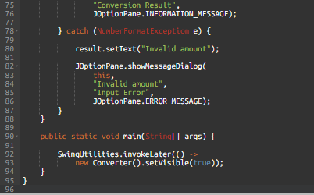
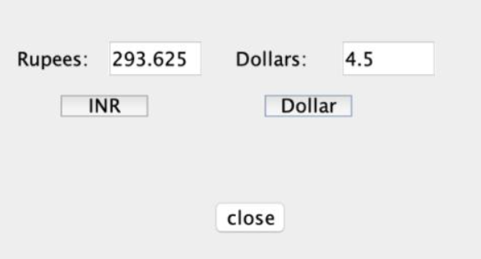
Task 5.3 – Compare the Styles
Feature | Frame listener | Named inner class | Anonymous inner class | Lambda
Readability | Good for small programs | Good for complex handlers | Can become lengthy | Short and simple
Access to frame fields | Direct | Direct | Direct | Direct
Reuse | Limited | Good | Limited | Good when stored in a variable
Code length | Medium | Medium | Longer | Short
Maintenance | Moderate | Good | Moderate | Good for simple actions

Which style is best for a large application?
- For a large application, named handler classes or reusable Swing Action objects are preferable because they separate event-handling logic from the interface.
- Lambda expressions are convenient for small operations.
Alternative Concept and Complexity Analysis
Instead of a lambda listener, we can use a method reference:
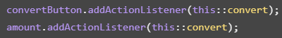
A shared Swing Action can also be registered with multiple controls
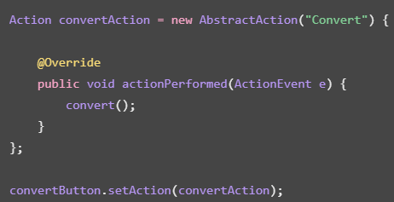
Method | Listener/action objects | Adding a new trigger
Separate anonymous listeners | May create multiple objects | Register another listener
Shared lambda | One shared handler object | Reuse the handler
Method reference | One shared handler reference | Reuse the method reference
Shared Swing Action | One reusable Action | Attach Action to new controls

Event dispatch itself is O(1) for a direct listener invocation. The main difference is the number of listener objects and the effort required to register new controls.
Conclusion
- The currency converter demonstrates four different ways of handling GUI events.
- The lambda version is concise and allows the same event handler to be used for both the Convert button and Enter key.
TASK 6 – DESIGN CHALLENGE
Problem: Campus Event Registration Desktop Application
- It combines Swing GUI design, event handling, JDBC database access, validation, duplicate prevention and background processing.
Task 6.1 – Interpret the Problem
Aim: To identify the users, screens, data and rules required for a campus event registration application.
A. Users
- Student: Registers for campus events.
- Committee member: Views, filters and exports registrations.
B. Screens
Screen | Purpose
Registration screen | Enter student details and select an event
Registration table | Display registered students
Filter section | Filter registrations by event
Export option | Export registration records
Dialog box | Display success and error messages

C. Data required
Field | Description
Registration ID | Unique registration number
Student ID | Student's register number
Student Name | Name of the student
Event Name | Selected campus event
Registration Date | Date and time of registration

D. Business rules
- Student ID must not be empty.
- Student name must not be empty.
- An event must be selected.
- A student cannot register twice for the same event.
- Multiple students can register for the same event.
- The committee can filter registrations by event.
- The committee can export registration details.
- Database loading must not freeze the GUI.
E. Testable requirements
Test | Expected result
Valid student registration | Registration saved
Empty student ID | Validation error
Empty student name | Validation error
No event selected | Validation error
Same student registers for same event again | Duplicate registration rejected
Filter by event | Only matching records displayed
Export registrations | CSV file generated
Database loading | Window remains responsive

Task 6.2 – Propose the Screen and Event Flow
Aim: To design the application screens and their navigation.
A. Screen sketch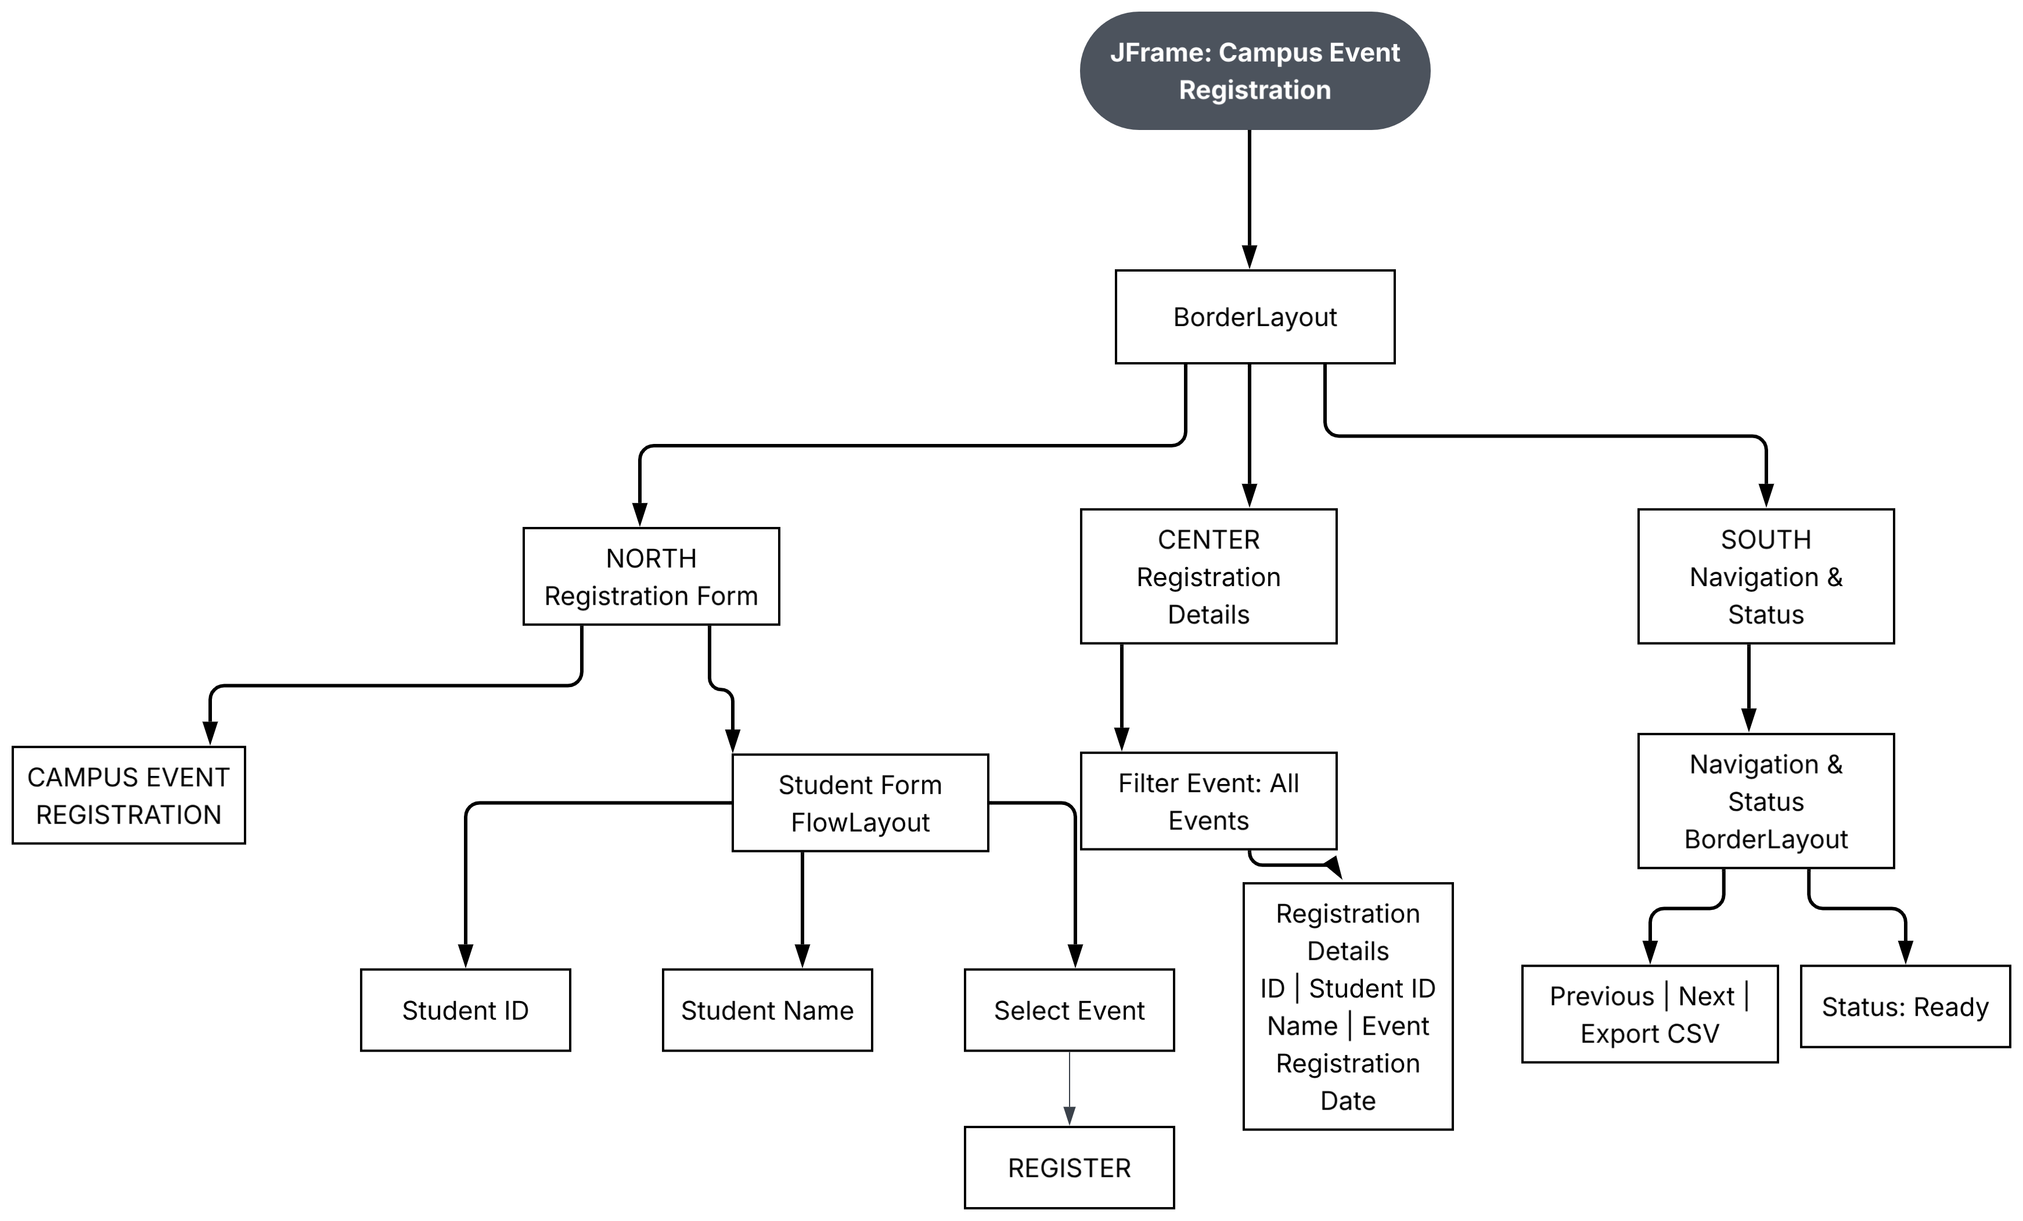
B. Menu bar
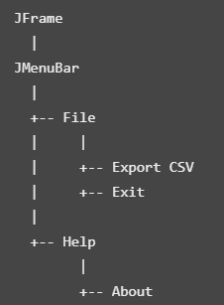

C. Event flow
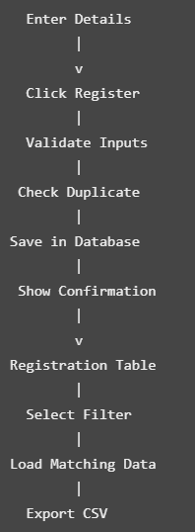
Task 6.3 – Identify the Critical Design Decisions
Aim: To identify where validation, duplicate checking and database operations should be performed.
Operation | Where performed | Reason
Input validation | Service layer | Prevent invalid input
Duplicate checking | Database and service layer | Prevent repeated registrations
Insert registration | JDBC DAO layer | Save registration details
Filter registrations | JDBC DAO layer | Retrieve matching records
Export records | JDBC DAO layer | Generate CSV
Long-running database work | SwingWorker | Keep GUI responsive

Important duplicate prevention
A simple Java check alone is not enough because two users could register at nearly the same time.
Therefore, create a database constraint:
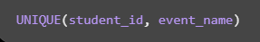
This guarantees that the same student cannot register twice for the same event, even if two requests arrive simultaneously.
Background database processing
Use SwingWorker:
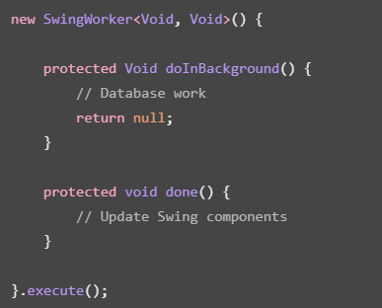
- doInBackground() performs database work away from the event-dispatch thread.
- done() updates the GUI after the background task completes.
Task 6.4 – Design the Classes and Handlers
Aim: To separate the GUI, service logic and JDBC operations.
A. Class diagram
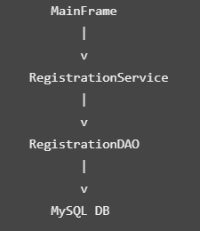
Class responsibilities:
Class | Responsibility
MainFrame | Displays the Swing interface
RegistrationService | Validates student details
RegistrationDAO | Performs JDBC operations
MySQL Database | Stores registration records

B. Pseudocode – Register action
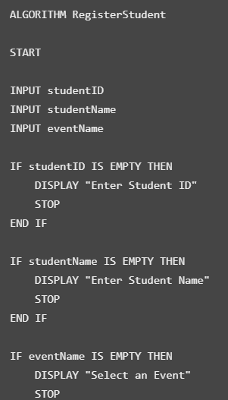
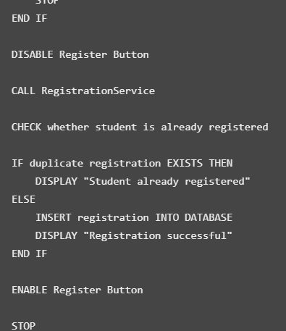
C. Pseudocode – Filter action
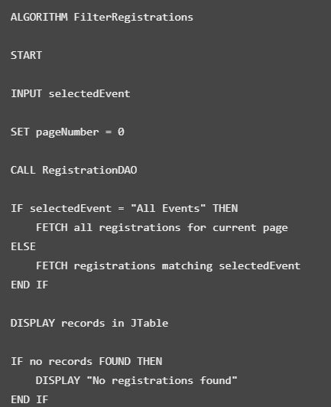
Task 6.5 – Implement and Demonstrate
Aim: To implement the campus event registration application using Swing, JDBC, MySQL and SwingWorker.
Step 1 – Create the MySQL database
Open MySQL Workbench or your MySQL command line and execute:
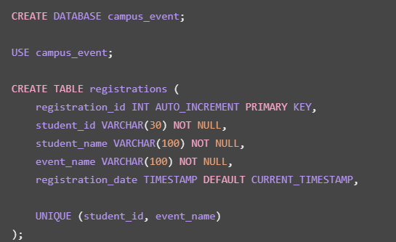
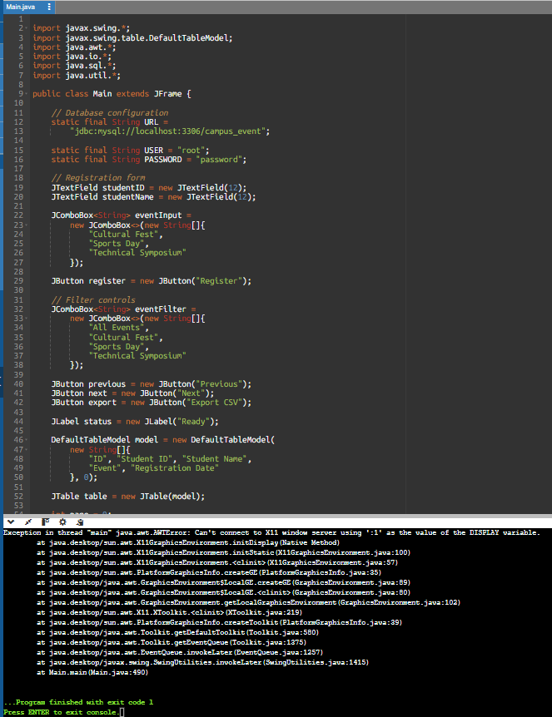
Alternative Concept and Complexity Analysis
Question: What happens if all registrations are loaded into the JTable at once instead of loading one page at a time using SQL LIMIT and OFFSET in a SwingWorker?
Method 1 – Load all registrations
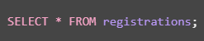
All 100,000 registration records are retrieved and stored in the JTable.
Method 2 – Load one page at a time
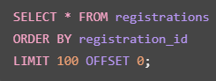
Only 100 records are retrieved per page. When the user clicks Next, the offset changes:
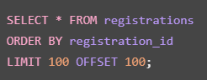
Feature | Load all records | Pagination
Records loaded | 100,000 | 100 per page
Initial loading | More data transferred | Less data transferred
Memory usage | O(n) | O(p) for displayed page
Database work | Retrieves all matching rows | Retrieves one page
GUI responsiveness | May be affected | Better when using SwingWorker
Navigation | Scroll through all rows | Previous and Next buttons

Here, n is the total number of registrations and p is the page size.
Time complexity:
- Loading all records requires O(n) work to retrieve and display n records.
- Loading one page requires approximately O(p) work for the returned records, plus database query and offset costs.
- With LIMIT and OFFSET, deeper pages may require the database to scan or skip more rows. An indexed keyset-pagination approach can improve this for very large datasets.
Space complexity:
- Loading all records requires O(n) memory for the retrieved records and table model.
- Pagination requires approximately O(p) memory for the current page.
Conclusion
- Pagination with SwingWorker is more suitable for 100,000 registrations because it reduces the amount of data held in the GUI and keeps database operations off the event-dispatch thread.
- Even loading all records through SwingWorker would keep the window more responsive than loading them directly on the event-dispatch thread, but it would still consume considerably more memory.

